**a)**

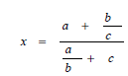

*x = (a + (b/c)) / ((a/b) + c)*

**b)**



*x = a + b + (a/b) / c*

**c )**

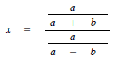

*x = ( a /( a+b)) / ( a / (a-b))*

**d)**

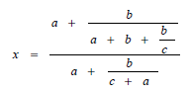

*x = (a + ( b / ( a + b + b / c) )) / ( a + ( b / ( c + a ) ))*

**E)**



*x =* ***( a + b + c ) / ( a + ( b / c ) )***

**F)**

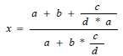

*x = (a + b + ( c / (d * a ) ) ) / ( a + b * ( c / d ))*

**g)**



*x = a + ( b / c ) + d / a*

**h)**

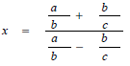

*x = a / b + b /c / a / b – b / c*

**i)**

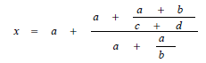

*x = a + ( a + ((a+b) / (c+d)) / a + (a/b) )*

**j)**

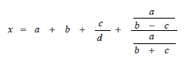

*x = a + b + (c/d) + (a/(b-c) / a/(b+c))*